List Comprehension

List comprehension offers a shorter syntax when you want to create a new list based on the values of an existing list.

If you want a new list, containing only the fruits with the letter "a" in the name.

Without list comprehension you will have to write a for statement with a condition

Example 0:

# to print all elements of a list

fruits = ["apple", "banana", "cherry", "kiwi", "mango"]

newlist = [x for x in fruits]

print(newlist)

Example 1:

# Create a new list out of the existing one which matches the letter 'e'

fruits = ["apple", "banana", "cherry", "kiwi", "mango"]

newlist = []

for x in fruits:

  if "e" in x:

    newlist.append(x)

print(newlist)

Example 2:

# Above example using list-comprehension

fruits = ["apple", "banana", "cherry", "kiwi", "mango"]

newlist = [x for x in fruits if "e" in x]

print(newlist)

Example 3:

# To filter the values which does not match the string 'mango'

fruits = ["apple", "banana", "cherry", "kiwi", "mango", "apple"]

print(fruits)

newlist = [x for x in fruits if x != "mango"]

print(newlist)

Example 4:

# Generating numbers using list-comprehension

newlist = [x for x in range(1,11)]

print(newlist)

Example 5:

# To get list of even numbers from 1 to 10

newlist = [x for x in range(1,11) if x%2==0]

print(newlist)

Example 6:

# Using title() function of a list of strings using list comprehension

fruits = ["apple", "banana", "cherry", "kiwi", "mango", "apple"]

newlist = [x.title() for x in fruits]

print(newlist)

Example 7:

# Return the item if it is not banana, if it is banana return orange

fruits = ["apple", "banana", "cherry", "kiwi", "mango", "banana"]

newlist = [x if x != "banana" else "orange" for x in fruits]

print(newlist)

Example 8:

# Tredetional way to convert a string characters to a list of char's

l = []

# Traditional approach of iterating

for character in 'Firstman Computers':

    l.append(character)

# Display list

print(l)

Example 9:

# Using list comprehension to iterate through loop

l = [x for x in 'Firstman Computer Training']

# Displaying list

print(l)

Example 10:

matrix = []

for i in range(3):

    # Append an empty sublist inside the list

    matrix.append([])

    for j in range(5):

        matrix[i].append(j)

print(matrix)

Example 11:

# Above prog using Nested list comprehension

matrix = [[j for j in range(5)] for i in range(3)]

print(matrix)

Example 12:

# Python program to remove multiple

# elements from a list using a condition

li=[10,13,15,20,25,24,28,30,32]

for i in list(li):

    if i % 5 == 0:

        li.remove(i)

print("List after removing elements ",li)

# list() is a fun used to typecast any group of values to a list.

x = 1,2,3,4,5

print(x)

print(type(x))

# convert the above tupel to a list

l = list(x)

print(l)

print(type(l))

Example 13:

# Python program to remove multiple

# elements from a list using list comprehension

li=[10,13,15,20,25,24,28,30,32]

li=[num for num in li if num%5!=0]

print("List after removing elements ",li)

# Python List Slicing

To access a range of items in a list, you need to slice a list. One way to do this is to use the simple slicing operator:

With this operator you can specify where to start the slicing, where to end and specify the step.

## Slicing a List

If L is a list, the expression L [start : stop : step ] returns the portion of the list from index start to index stop, at a step size step.

### Syntax

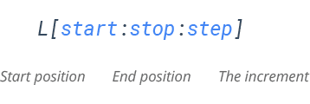

### Basic Example

Here is a basic example of list slicing.

L = ['a', 'b', 'c', 'd', 'e', 'f', 'g', 'h', 'i']

print(L[2:7])

# Prints ['c', 'd', 'e', 'f', 'g']

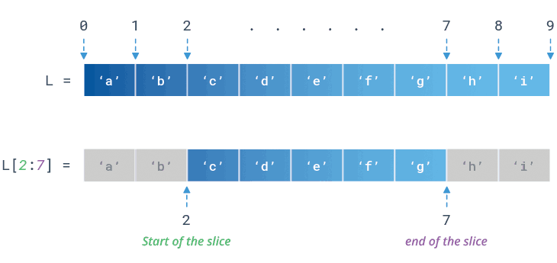

Note that the item at index 7 'h' is not included.

## Slice with Negative Indices

You can also specify negative indices while slicing a list.

L = ['a', 'b', 'c', 'd', 'e', 'f', 'g', 'h', 'i']

print(L[-7:-2])

# Prints ['c', 'd', 'e', 'f', 'g']

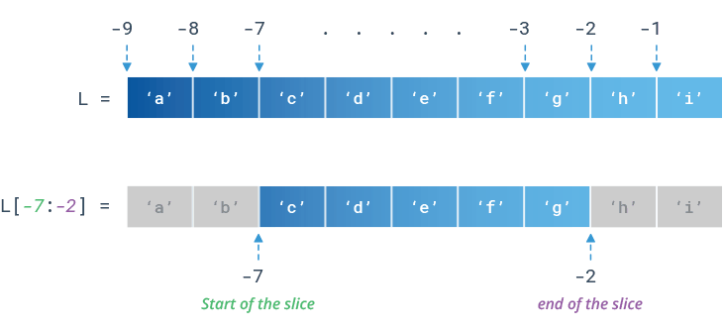

## Slice with Positive & Negative Indices

You can specify both positive and negative indices at the same time.

L = ['a', 'b', 'c', 'd', 'e', 'f', 'g', 'h', 'i']

print(L[2:-5])

# Prints ['c', 'd']

## Specify Step of the Slicing

You can specify the step of the slicing using step parameter. The step parameter is optional and by default 1.

# Return every 2nd item between position 2 to 7

L = ['a', 'b', 'c', 'd', 'e', 'f', 'g', 'h', 'i']

print(L[2:7:2])

# Prints ['c', 'e', 'g']

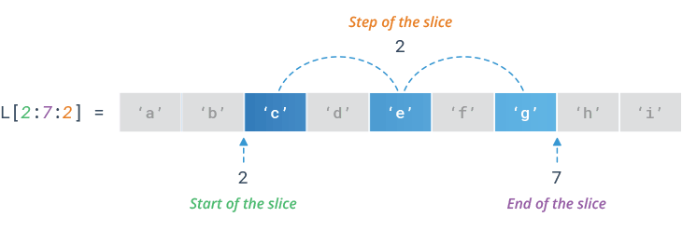

### Negative Step Size

You can even specify a negative step size.

# Return every 2nd item between position 6 to 1

L = ['a', 'b', 'c', 'd', 'e', 'f', 'g', 'h', 'i']

print(L[6:1:-2])

# Prints ['g', 'e', 'c']

## Slice at Beginning & End

Omitting the start index starts the slice from the index 0. Meaning, L[:stop] is equivalent to L[0:stop]

# Slice the first three items from the list

L = ['a', 'b', 'c', 'd', 'e', 'f', 'g', 'h', 'i']

print(L[:3])

# Prints ['a', 'b', 'c']

Whereas, omitting the stop index extends the slice to the end of the list. Meaning, L[start:] is equivalent to L[start:len(L)]

# Slice the last three items from the list

L = ['a', 'b', 'c', 'd', 'e', 'f', 'g', 'h', 'i']

print(L[6:])

# Prints ['g', 'h', 'i']

## Reverse a List

You can reverse a list by omitting both start and stop indices and specifying a step as -1.

L = ['a', 'b', 'c', 'd', 'e']

print(L[::-1])

# Prints ['e', 'd', 'c', 'b', 'a']

## Modify Multiple List Values

You can modify multiple list items at once with **slice assignment**. This assignment replaces the specified slice of a list with the items of assigned **iterable**.

# Modify multiple list items

L = ['a', 'b', 'c', 'd', 'e']

L[1:4] = [1, 2, 3]

print(L)

# Prints ['a', 1, 2, 3, 'e']

# Replace multiple elements in place of a single element

L = ['a', 'b', 'c', 'd', 'e']

L[1:2] = [1, 2, 3]

print(L)

# Prints ['a', 1, 2, 3, 'c', 'd', 'e']

## Insert Multiple List Items

You can insert items into a list without replacing anything. Simply specify **a zero-length slice.**

# Insert at the start

L = ['a', 'b', 'c']

L[:0] = [1, 2, 3]

print(L)

# Prints [1, 2, 3, 'a', 'b', 'c']

# Insert at the end

L = ['a', 'b', 'c']

L[len(L):] = [1, 2, 3]

print(L)

# Prints ['a', 'b', 'c', 1, 2, 3]

You can insert items into the middle of list by keeping both the start and stop indices of the slice same.

# Insert in the middle

L = ['a', 'b', 'c']

L[1:1] = [1, 2, 3]

print(L)

# Prints ['a', 1, 2, 3, 'b', 'c']

## Delete Multiple List Items

You can delete multiple items out of the middle of a list by assigning the appropriate slice to an empty list.

L = ['a', 'b', 'c', 'd', 'e']

L[1:5] = []

print(L)

# Prints ['a']

You can also use the del statement with the same slice.

L = ['a', 'b', 'c', 'd', 'e']

del L[1:5]

print(L)

# Prints ['a']

## Clone or Copy a List

When you execute new_List = old_List, you don’t actually have two lists. The assignment just copies the reference to the list, not the actual list. So, both new_List and old_List refer to the same list after the assignment.

You can use slicing operator to actually copy the list (also known as a shallow copy).

L1 = ['a', 'b', 'c', 'd', 'e']

L2 = L1[:]

print(L2)

# Prints ['a', 'b', 'c', 'd', 'e']

print(L2 is L1)

# Prints False